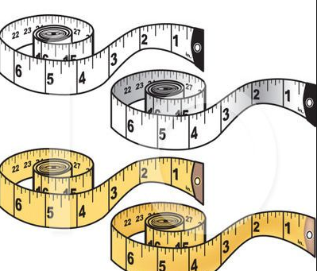
CS 1010 Lab5 – Tailor Made!
10 Points
Due: 10/19 Falcon Fashion

Propose:
In this lab, you will complete a Python program with one partner. This lab will help you with the practice modularizing a Python program.

Instructions (Ask for guidance if necessary):
- To speed up the process, follow these steps.
  - Create a file called ###_###lastnamelab5.py onto your desktop (use your class codes for ### and your last name)
  - Launch Pyscripter and open the .py file from within Pyscripter.

- Creat your own banner and add your class codes and names at the top as following:
#Name : ###YourLastName
#Name : ###YourLastName

- This Python program will complete the following program description (looks familiar!)

A. Write a complete Python program with a main function that inputs a user’s height, weight and age as floats. Then compute clothing sizes according to the formulas given below, using a separate function (called from the main function) for each calculation. Lastly, call a printSizes funcction from the main function to display the results.

B. Write the function, called by the main function. Determine the correct arguments and parameter. What is needed for the calculations and what is returned? Use the following equation:

Hat size = Weight / Height * 2.9

C. Write the function, called by the main function. Determine the correct arguments and parameter. What is needed for the calculations and what is returned? Use the following equation:

Sweater size = (Height * Weight / 301) + (1 / 8 * (Age // 10))

D. Write the function, called by the main function. Determine the correct arguments and parameter. What is needed for the calculations and what is returned? Use the following equation:

Waist size = (Weight / 5.7) + (0.1 * (Age // 2))

E. Write the function, called by the main function. Have the function display the following output below? Determine the correct arguments and parameter.

- Run your code with the following input yielding the following output

Height Weight Age a. b. c.
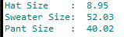
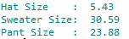
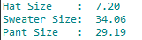
        - 70 131 19
        - 64 159 27
        - 71 219 32
** Once you have produced the 3 correct output results, call me or the GA over to check your code and output. There will be no need to turn it in unless you don’t finish in time. You should however, save a copy for yourself. Email it to yourself if you don’t have a means of storage.

*** If you complete the lab before Thursday night @ 7pm, you know what to do…right???? Make a snip of your output and submit an output file along with your python file.

